YX-6501硬币清分包装系统
TSJ-001 YX-6501硬币清分包装系统是集硬币的高速清分、检伪、包装与一体的新颖设备，该系统采用德国REIS公司的核心技术，主要应用公交、银行库房等硬币处理量较大的企业，并由传感器控制形成联动方式，自动完成硬币的输入及输出。经该系统清分、检伪后包装好的成卷硬币，符合回笼硬币处理后的二次投放要求。  技术参数： | 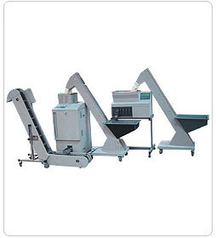
  清分、包装速度： | 1200-1500枚/分钟
  日处理能力： | 20万枚-30万枚
  体 积： | 2550（长）×800（宽）×1500（高）mm  约占面积2平方米
  功 耗： | 800瓦
  电 源： | 220V/50Hz

YX-6501 Coin Sorting and Wrapping System
YX-6501 Coin Sorting and Wrapping System is integrated equipment consisting of high speed sorting, detection and wrapping features. Installed with German Reis core technologies, the machine is applicable to public transportation, banking vault where mass coins are handled. The different parts of the system can work jointly controlled by sensors and auto input and output can be realized. The output coins from this system are wrapped into rolls, meet the demands to re-issue the coins after collection.
Technical Specifications：
Sorting and Wrapping Speed: | 1200-1500pcs/min
Daily Processing Capacity : | 200,000-300,000pcs
Numbers of Sortable Coins: | 2550（L）×800（W）×1500（H）mm
Covering : | approx. 2 square meters
Power Consumption : | 800W
Power Supply | 220V/50Hz

