YFJ-504清分机
YFJ-504硬币（高速）检伪清分计数机是国内首创的高速硬币检伪清分设备，每分钟清分速度高达1500-1800枚，与硬币包装机同时被科学技术部评定为重点国家级火炬计划项目。
该机根据硬币的尺寸和材质特点，在特定的轨道上通过自行设计的专用传感器对不同直径、不同面值的硬币进行检测、计算、判别，实现硬币的检伪功能。同时该机可计算出所清分硬币的数量、金额及所有硬币的总数量及总金额，还可以通过内置式打印机或标准RS232接口进行数据输出。
技术参数：
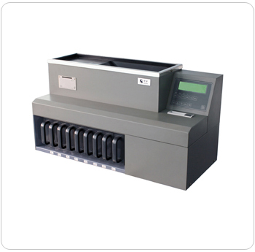
检伪方式： | 对硬币质量进行综合判别
清分硬币的种类： | 可同时清分现有人民币硬币（7种）
计数方式: | 连续计数/预置计数/混合计数
清分结构： | 直轨式
清分速度： | 1500-1800枚/分钟
储币斗容量： | 12000枚
清分硬币直径： | φ14mm-34mm
清分硬币厚度： | ≤4mm
显示方式： | 液晶中文显示
整机净重： | 60公斤
数据处理: | 可计算每种硬币的数量及金额，和被清分硬  币的|总数量、总金额，并显示和储存。
尺 寸： | 820（长）×360（宽）×450（高）mm
YFJ-504 Coin Sorter
YFJ-504 coin sorter is the first high speed coin sorting and detecting machine developed in China with the speed at 1500-1800pcs/min. Together with the coin wrapper ,it is listed in the National Key Torch Programs.
Based on the dimension and material of coins, specially developed sensors installed on the track detect, count and identify the coins of different diameters and values to realize the authentication detection. The machine can also calculate the numbers, amount and grand numbers and total value of all the coins. The machine can be configured with internal printer and standard RS232 interfa
Detection Mode: | Comprehensive detection of coins.
Numbers of Sortable Coin  Denomination: | 6 denominations
Sorting Mechanism: | Belt sorting
Sorting Speed: | 1500-1800/min
Hopper Capacity: | 12000pcs  Mix Counting
Counting Mode: | Continuous Counting Batch  Counting Mixed Counting
Sortable Coin Diameter: | 14mm-34mm
Sortable Coin Thickness: | 1-3.2mm
Data Processing: | calculate the numbers and amount of each denomination and grand numbers and amount  of the counted coins and display and save them.
Display: | LCD
Net Weight: | 60Kg
Power Consumption: | 300W
Power Supply: | AC220V/50Hz, 110V/60Hz
Dimension | 666（L）×330（W）×460（H）mm

