YFJ-502硬币（高速）混计数机
YFJ-502硬币（高速）混计数机是国内首创可对不同直径硬币进行混合检伪计数的高性能新产品。该机根据硬币的尺寸和材质特点，在特定的轨道上通过自行设计的专用传感器对不同直径、不同面值的硬币进行检测、计算、判别，实现硬币的检伪功能。同时该机可计算出所清分硬币的数量、金额及所有硬币的总数量及总金额，还可配备外接打印机进行书面输出。该产品主要应用在银行金融系统、大型超市和公交企业等。
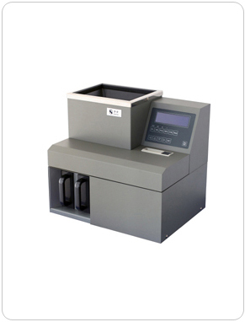
技术参数：
检伪方式： | 对硬币质量进行综合判别
清分硬币的种类： | 可清分所有人民币硬币
计数方式: | 连续计数/预置计数/混合计数
清分结构： | 直轨式
清分速度： | 1500-1800枚/分钟
储币斗容量： | 12000枚
清分硬币直径： | φ14mm-34mm
清分硬币厚度： | ≤4mm
显示方式： | 液晶中文显示
整机净重： | 40.8公斤
数据处理: | 可计算每种硬币的数量及金额，和被清分硬  币的|总数量、总金额，并显示和储存。
尺 寸： | 510（长）×330（宽）×460（高）mm
功 耗： | 300瓦

YFJ-502 High Speed Coin Counter
YFJ-502 high speed coin counter is the first machine in China which can count mixed coins of different diameters. Based on the dimension and material of coins, specially developed sensors installed on the track detect, count and identify the coins of different diameters and values to realize the authentication detection. The machine can also calculate the numbers, amount and grand numbers and total value of all the coins. The machine can be configured with external printer and standard RS232 interface. The machine is applicable in banks, financial systems, supermarkets and public transportations companies etc.
Technical Specifications:
Detection Mode: | Comprehensive detection of coins.
Numbers of  Sortable Coin  Denomination: | All the existing RMB coins in  circulation (7 denominations)
Sorting Mechanism: | Belt sorting
Sorting Speed: | 1500-1800/min
Hopper Capacity: | 12000pcs
Counting Mode: | Continuous Counting Batch Counting Mixed Counting
Sortable Coin  Diameter: | 14mm-34mm
Sortable Coin Thickness: | 1-3.2mm
Data Processing: | calculate the numbers and amountof eachdenomination and grand numbers  and amount of the counted coins and  display and save them.
Display: | LCD
Net Weight: | 40.8Kgs
Power Consumption: | 300W
Power Supply: | AC220V/50Hz
Dimension | 510（L）×330（W）×460（H） mm

