YFJ-304硬币检伪清分机
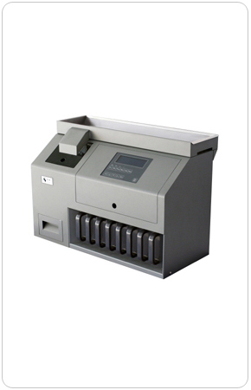
YFJ-304硬币检伪清分计数机是苏州少士电子科技有限责任公司与德国REIS公司技术合作生产的，是国内独创的动态“以真防假”检伪及独特的多币种同时检伪和清分计数的高性能中速硬币清分设备。
该机根据硬币的尺寸和材质特点，在特定的轨道上通过自行设计的专用传感器对不同直径、不同面值的硬币进行检测、计算、判别，实现硬币的检伪功能。同时该机可计算出所清分硬币的数量、金额及所有硬币的总数量及总金额，还可以配置外接打印机或标准RS232接口进行数据输出。
技术参数：
检伪方式： | 对硬币质量进行综合判别
清分硬币的种类： | 可同时清分现有人民币硬币（7种）
清分结构： | 斜轨式
清分速度： | 600枚/分钟
储币斗容量： | 600-12000枚
计数方式： | 连续计数/预置计数/混合计数
清分硬币直径： | 14mm-34mm
清分硬币厚度： | ≤4mm
数据处理： | 可计算每种硬币的数量及金额，和被清分硬币的总  数量、总金额，并显示和储存。
显示方式： | 液晶显示
整机净重： | 40Kg
功 耗： | 80瓦
电 源： | AC220V/50Hz
尺 寸： | 680（长）×300（宽）×420（高）mm
环境温度： | 0-40℃
湿 度： | 30-75%

YFJ-304 Coin Sorter
YFJ-304 Coin Sorter is a cooperative product between Suzhou South Science Technology Electronic Co. Ltd and Reis Company in Germany. In China it is the unique middle speed reliable machine installed with the technology “anti-fake by the genuine” and can count and detect different coins. According to the dimension and material of coins and with the specially developed sensors installed on the track detect, the machine can count and identify the coins of different diameters and values and realize the coin authentication. Besides, it can also calculate the numbers, amount and grand numbers and total value of all the coins. The machine can be configured with external printer and standard RS232 interface.
Technical Specifications:
Detection Mode: | Comprehensive detection of coins.
Numbers of Sortable Coin  Denomination: | 8 denominations
Sorting Speed: | 600pcs/min
Hopper Capacity： | 600-12000pcs
Counting Mode： | Continuous Counting Batch Counting  Mix Counting
Sortable Coin Diameter： | 14mm-34mm
Data Processing： | calculate the numbers and amount of each denomination and grand numbers and  amount of the counted coins and display and save them.
Net Weight: | 40Kg
Power Consumption: | 80W
Power Supply: | AC220V/50Hz, 110V/60Hz
Dimension: | 680（L）×300（W）×420（H）mm
Ambient Temperature： | 0-40℃
Ambient Humidity： | 30-75%

