YFJ-200硬币计数机
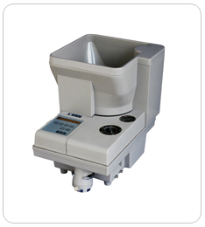
YFJ-200硬币计数机配有大容量储币斗，可根据硬币或筹码的外径尺寸和厚度，从机械上保证硬币或筹码在特定的离心作用下运动，通过可调轨道进行单一币种的挑选和计数，且可对硬币或筹码数量进行分别预置、存储和累加。该产品主要应用在金融系统、公交、邮电、地铁、娱乐等企业。
技术参数：
分拣速度： | 1500枚/分钟
分拣盘容量： | 4300枚
分拣硬币直径： | 14-34mm
分拣硬币厚度： | 0.8-3.8mm
币种号： | 0-9（10种）
计数方式： | 连续计数/预置计数
电 源： | 220V/50HZ
功 耗： | 80瓦
整机净重： | 12.5公斤
体 积： | 375（长）×265（宽）×320（高）mm

YFJ-200 Coin Counter
YFJ-200 coin counter, with a big hopper, counts coins or tokens by diameter and thickness. Mechanically it transports the coins through certain centrifugal force. The track is adjustable for single denomination selection and counting. It is also featured with Batch, Storage and Accumulation. The machine is applicable in the fields such as financial systems, public transportation, postal offices, subway and entertainment etc.
Technical Specifications：
Speed: | 1500pcs/min
Hopper Capacity: | 4300pcs
Countable Coin Diameter: | 14-34mm
Countable Coin Thickness: | 0.8-3.8mm
Coin Codes: | 0-9(10 numbers)
Counting Modes: | Continuous counting/ Batch counting
Power Supply: | 220V/50Hz, 110V/60Hz
Power Consumption: | 80W
Net Weight: | 12.5KG
Dimension: | 375(L)×265(W)×320(H)mm

