YBJ-601全自动硬币包装机
YBJ-601全自动硬币（高速）包装机是德国REIS公司全套整机技术，由苏州少士电子科技有限责任公司在国内自主生产的全自动硬币包装机。该机可对不同直径、不同厚度及每卷的枚数硬币进行全自动记数、包装，并可在记数包装的过程中剔除小直径硬币，具有硬币分拣的功能。该机具有开机自我诊断、故障提示、运行状态显示和枚数、币种、卷数的计算功能。其独有的双计数传感器确保了每卷硬币数量的准确性，数差的精确率可控制在十万分之二以内。
技术参数：
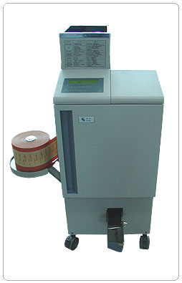
盛币斗容量: | 17000枚
可包装币种: | 满足现行流通的人民币硬币（7种）
分拣功能: | 在计数包装过程中，能清分出小直径硬币（例如：在  包1元硬币时能清分出5角、1角等次直径硬币）。
叠币高度: | 30 mm-110 mm
包装硬币厚度: | 1mm-3.4mm
功 耗: | 600瓦
电 源: | 220V/50HZ
环境温度: | 5-35℃
包装速度: | 35卷/分钟
每卷包装容量: | 可根据要求每卷包成25枚、40枚及50枚不规格。
包装标识: | 采用统一印刷的进口全木浆俄罗斯牛皮纸，同时根  据 .面值的不同采用不同颜色印刷区别，并列明每卷  硬币的面值、枚数及金额
包装硬币直径: | 15 mm -33 mm
整机净重: | 140公斤
外形尺寸: | 1180（高）×455（宽）×585（深）mm
相对湿度: | 30-80%

YBJ-601 fully automatic high speed coin wrapping machine
Wrapping Speed: | 35 rolls/min(YBJ-601) (coin diameter22mm)
Coin RollCapacity: | 25-50 pcs/roll
Stacking Height: | 30-110mm
WrappableCoinThickness | 1mm—3.4mm
WrappableCoinDiameter: | 15mm – 33mm
Hopper Capacity: | 400pcs
Display: | LCD
Power Consumption: | 600W
Weight: | 140kg
Dimension: | 1180（H）×455（W）×585（D）mm
Power Supply: | 220V±10%
Ambient Temperature: | 5-35℃
Ambient Humidity: | 30-80%
Sorting Function: | smaller denominations can be sorted out when wrapping bigger one(e.g. 50 cents can be sorted out when wrapping 1 RMB coins). Wrapping Paper: Kraft paper from Russia. Different denominations are printed with different color with single value, pieces and total value on the paper
YBJ-601 fully automatic high speed coin wrapping machine are installed with the entire finished machine technology from Reis in Germany but completely produced by Suzhou South Science Technology Electronic Co,. Ltd. This machine can automatically count and wrapper the coins of different diameters and thickness. Smaller diameter coins will be sorted out during wrapping bigger denomination. The machine is configured with such features as self-diagnosis when power-on ,failure information display, status information display and coin number ,denomination and rolls calculation. The unique double count sensor system ensures the counting precision of each roll and the failure tolerance can be controlled under 0.02 percent.
Technical Specifications:

