PRC-960多国货币点钞机

性能特征：  PRC-960多国货币点钞机是我司多年生产TELLAC-9C型多国货币点钞机的经验积累基础上生产的技术升级产品，该机应用创新的图像识别及面值检伪技术，采用高端的货币防伪手段，权重柜面精制版假钞的精确识别。  多种币兼容：能同时兼容处理美元、欧元、港币、英镑、日元的检伪清点。专版检伪：应用创新的图像识别技术，能对美元、欧元、港币及英镑四种货币的任一面值进行专版检伪，权重柜面精制版假钞的精确识别，其美元的防伪能力处于国际领先水平。同时该机对于美元的处理，不受新旧版和年版的限制。  面值分拣（挑夹版）：能将美元、欧元、港币及英镑四种货币的任一面值中混入的其他面值钞票轻松挑选出来，精确鉴别变造假币。  面值混计数：能对美元、欧元、港币及英镑四种货币的不同面值进行混合计值，并可分别列表显示各面值钞票的张数、金额及总金额。该机是国内首台可进行多币种面值混合计数、计值的高性能面值混计数机。 | 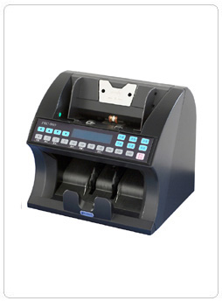

PRC-960 Foreign Currency Counter

Based on the long-year experience of Tellac-9C multinational currency counter, PRC-960 is an upgraded technological product, which applies the innovative image recognition and value-reading counterfeit detections. Equipped with the edge-cut techniques, accurate detection against counterfeits is realized on this model.
Target Currencies： US Dollar, Euro, HK Dollar, GBP, and Japanese Yen can be counted and detected on one machine.
Detection of Special Versions: with the innovative image recognition technology, the machine is designed for the authentication detection of any single special version of US Dollar, Euro, HK Dollar and GBP. The anti-fake detection on US Dollar is in the world’s leadership. Any version and issue of US Dollar can be handled.
Wrong-Denomination-Picking-Out: For US Dollar, Euro, HK Dollar, and GBP, the machine can pick out wrong denominations easily and detect the faked notes.
Mixed Value Counting: The machine is able to count the value of mixed banknotes of US Dollar, Euro, HK Dollar and GBP respectively and display the numbers, amount and total sum of the counted notes. It is the first machine in China which can count the value of mixed denominations and handle different currencies at the same time.
Countable Currencies： | US Dollar, Euro, HK Dollar, GBP and Japanese Yen. Any version of US Dollar can be handled.
Speed： | 3 levels , 1400 pcs / min,  1200pcs/min, 900pcs/min.
StackerCapacity： | 200pcs
Counting Modes: | Auto reset, Batch stop, Accumulation and mixed value counting
Batch： | Fixed numbers 5、10、25、50、100 or random numbers through 0-9 keys.
Detection Features: | UV, MG, IR, FL, STC, Image Recognition, Width, Chain Feed, Double Feed, Half  Note, Skew Feed
Dimension： | 310（L）×250（W）×220（H）mm

